**GrainsMart**

**UML DIAGRAMS**

**Name:** Shubham Hiralal Giramkar

**Roll No:** 22318

**Class:** FY-MCA

**Div:** C

**Project Guide:** Dr. Milind Godase

CLASS DIAGRAM

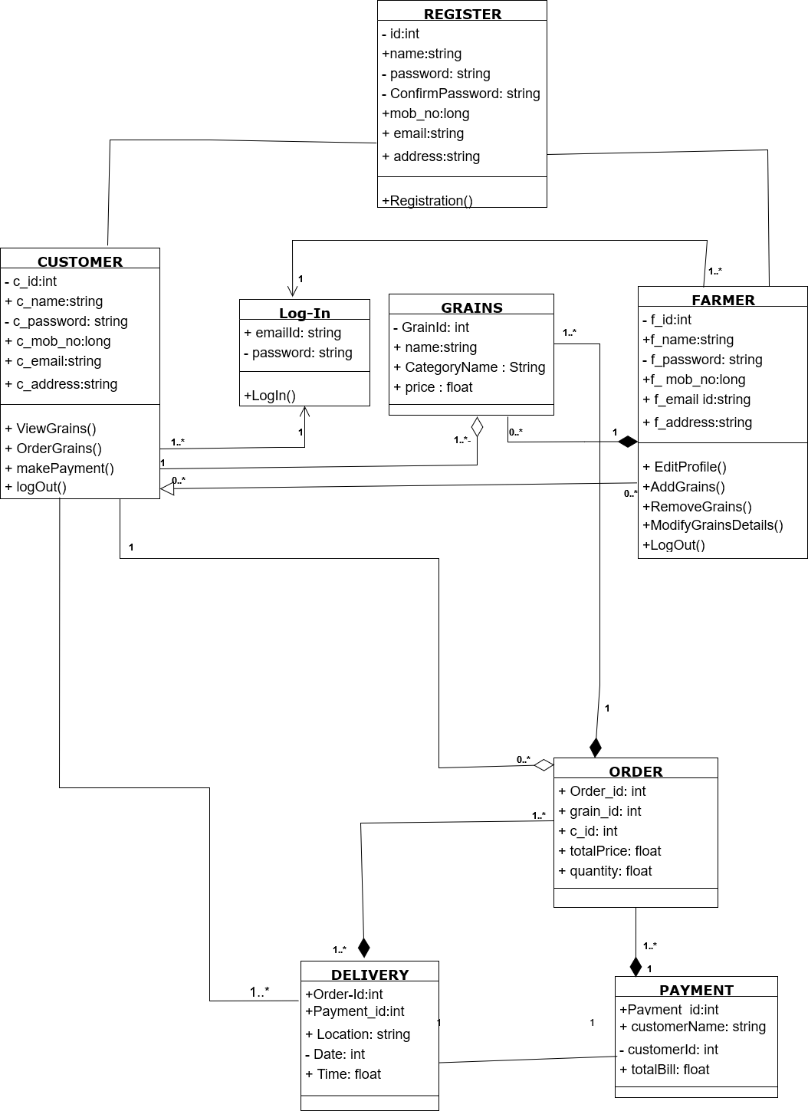

USE CASE DIAGRAM FOR CUSTOMER

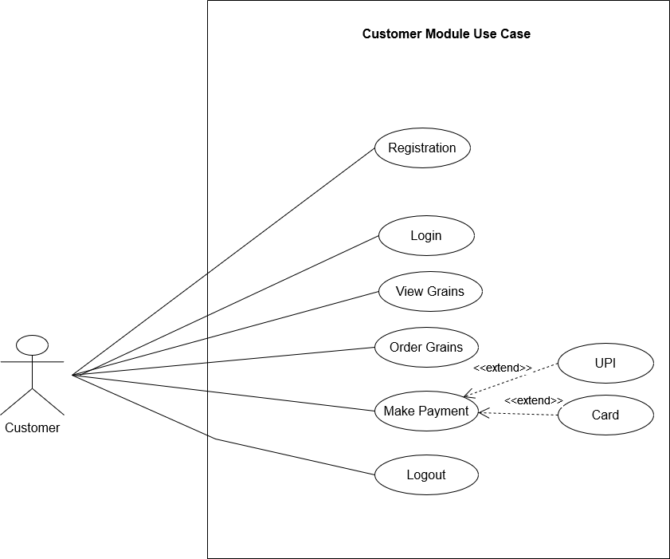

USE CASE DIAGRAM FOR FARMER

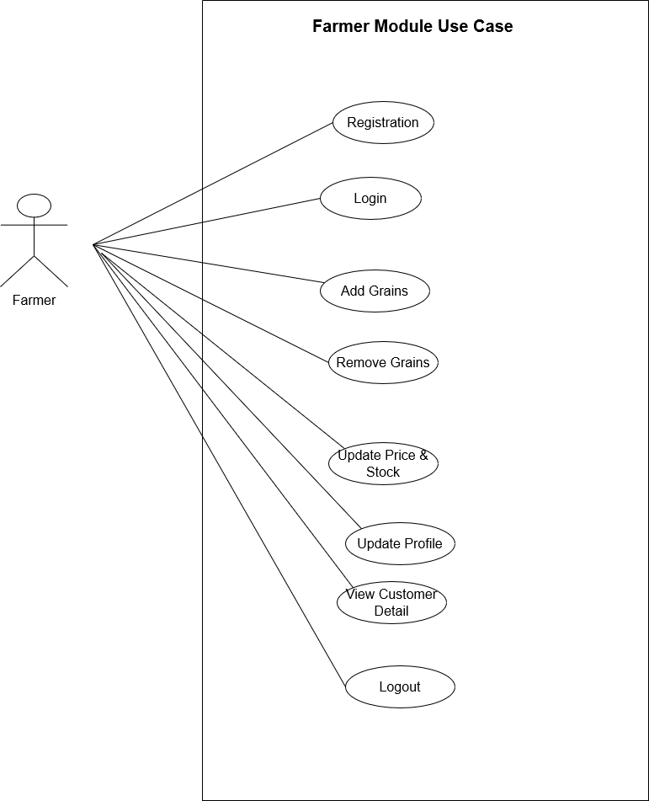

USE CASE DIAGRAM FOR SYSTEM

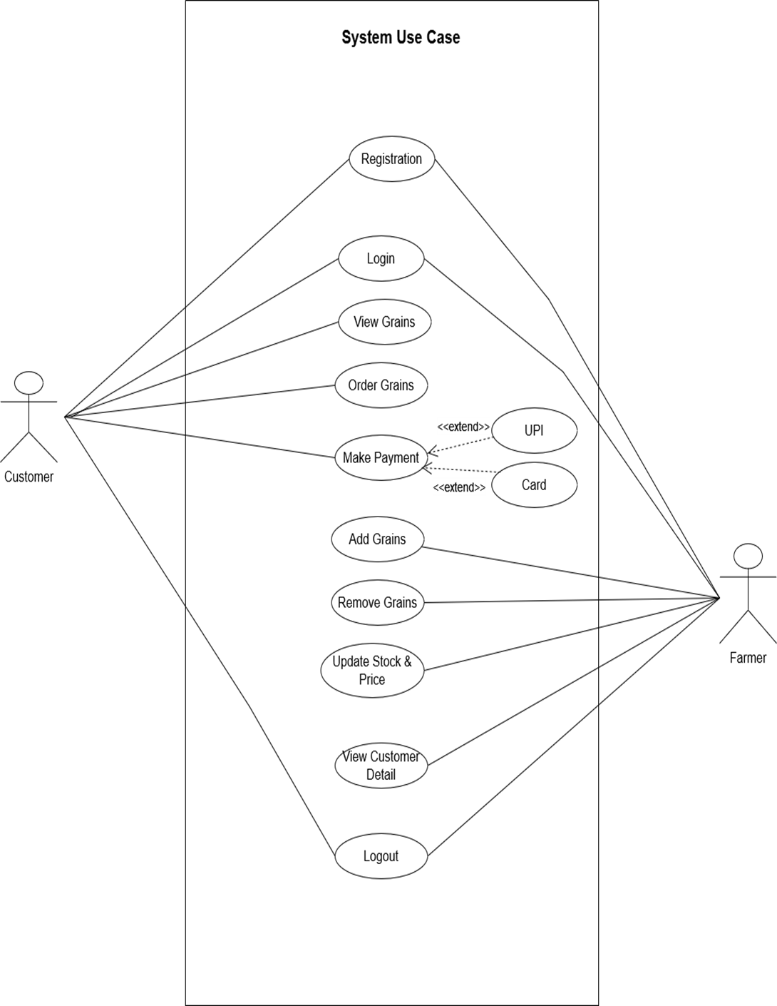

ACTIVITY DIAGRAM FOR CUSTOMER

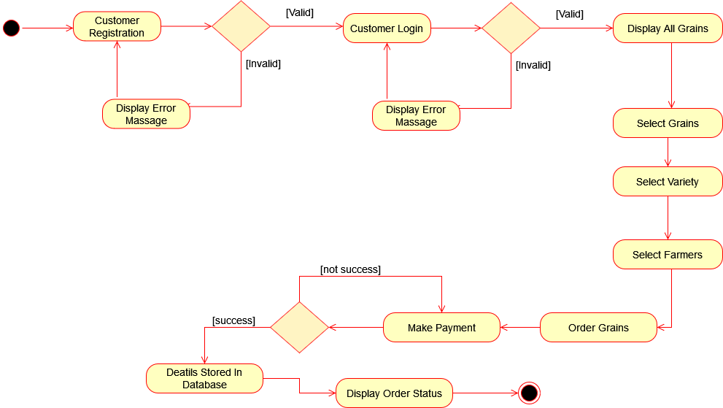

ACTIVITY DIAGRAM FOR FARMER

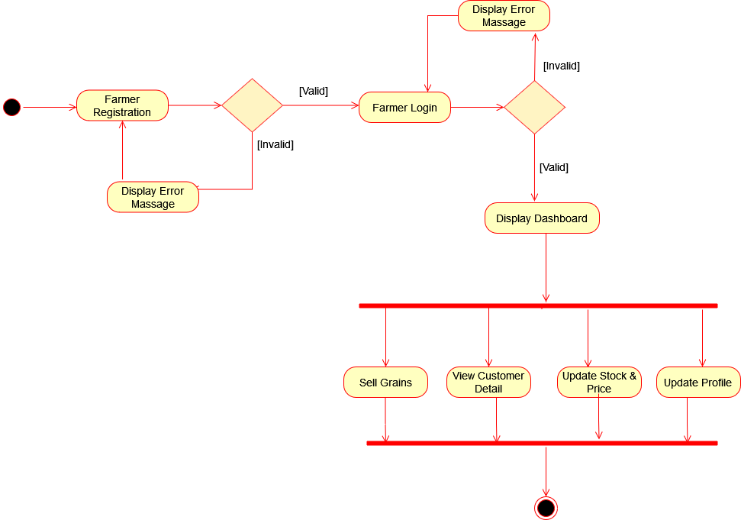

TABLE SPECIFICATION

TABLE NAME: Customer

|  |  |  |  |
| --- | --- | --- | --- |
| **Field name** | **Datatype** | **Size** | **Constraints** |
| C_id | int | 10 | Primary key |
| C_username | varchar | 10 | Not null |
| C_password | varchar | 12 | Not null |
| C_Name | varchar | 10 | Not null |
| C_email | varchar | 20 | Not null |
| C_MobileNo | int | 10 | Not null |
| C_Address | varchar | 20 | Not null |

TABLE NAME: Farmer

|  |  |  |  |
| --- | --- | --- | --- |
| **Field name** | **Datatype** | **Size** | **Constraints** |
| f_id | int | 10 | Primary key |
| f_username | varchar | 10 | Not null |
| f_password | varchar | 12 | Not null |
| f_Name | varchar | 10 | Not null |
| f_email | varchar | 20 | Not null |
| f_MobileNo | int | 10 | Not null |
| f_Address | varchar | 20 | Not null |

TABLE NAME: Orders

|  |  |  |  |
| --- | --- | --- | --- |
| **Field name** | **Datatype** | **Size** | **Constraints** |
| Order_id | int | 10 | Primary Key |
| Grains_id | int | 10 | Foreign key |
| C_id | int | 10 | Foreign Key |
| f_id | int | 10 | Foreign key |
| Order_quantity | int | 5 | Not null |
| Total_bill | int | 10 | Not null |
| Order_Date_time | date | -- | Not null |
| Delivery_address | varchar | 20 | Not null |

TABLE NAME: Grains

|  |  |  |  |
| --- | --- | --- | --- |
| **Field name** | **Datatype** | **Size** | **Constraints** |
| Grain_id | int | 10 | Primary key |
| Grain_Name | varchar | 20 | Not null |
| Grain_Variety | varchar | 20 | Not null |
| Grain_price | int | 10 | Not null |
| Total_Stock | int | 10 | Not null |

TABLE NAME: Payments

|  |  |  |  |
| --- | --- | --- | --- |
| **Field name** | **Datatype** | **Size** | **Constraints** |
| Payment_id | int | 10 | Primary key |
| Order_id | int | 10 | Foreign key |
| C_id | int | 10 | Foreign key |

DATA DICTIONARY

|  |  |  |  |  |  |
| --- | --- | --- | --- | --- | --- |
| **Field name** | **Datatype** | **Size** | **Constraints** | **Description** | **Table Name** |
| f_id | int | 10 | Primary key | Represent Farmer Id | Farmer,Orders |
| f_username | varchar | 10 | Not null | Represent Farmer Username | Farmer |
| f_password | varchar | 12 | Not null | Represent Farmer login password | Farmer |
| f_Name | varchar | 10 | Not null | Represent Farmer name | Farmer |
| f_email | varchar | 20 | Not null | Represent Farmer email | Farmer |
| f_MobileNo | int | 10 | Not null | Represent Farmer MobileNo | Farmer |
| f_Address | varchar | 20 | Not null | Represent Farmer Address | Farmer |
| C_id | int | 10 | Primary key | Represent Customer Id | Customer,Orders,Payments |
| C_username | varchar | 10 | Not null | Represent Customer Username | Customer |
| C_password | varchar | 12 | Not null | Represent Customer password | Customer |
| C_Name | varchar | 10 | Not null | Represent Customer name | Customer |
| C_email | varchar | 20 | Not null | Represent Customer email | Customer |
| C_MobileNo | int | 10 | Not null | Represent Customer MobileNo | Customer |
| C_Address | varchar | 20 | Not null | Represent Customer Address | Customer |
| Order_id | int | 10 | Primary Key | Represent Order Id | Orders,Payments |
| Order_quantity | int | 5 | Not null | Represent Order Quantity | Orders |
| Total_bill | int | 10 | Not null | Represent Total Bill | Orders |
| Order_Date_time | date | -- | Not null | Represent Order Date&Time | Orders |
| Delivery_address | varchar | 20 | Not null | Represent Delivery Address | Orders |
| Grain_id | int | 10 | Primary key | Represent Grain id | Grains,Orders |
| Grain_Name | varchar | 20 | Not null | Represent Grain Name | Grains |
| Grain_Variety | varchar | 20 | Not null | Represent Grain Variety | Grains |
| Grain_price | int | 10 | Not null | Represent Grain price | Grains |
| Total_Stock | int | 10 | Not null | Represent Total Stock | Grains |
| Payment_id | int | 10 | Primary key | Represent Payment Id | Payments |